For More Information Please Contact:

Lake Ridge French Dual Language School
7900 Lake Ridge Circle
Riverdale, GA 30296
770-907-5170

1058 Fifth Avenue
Jonesboro, GA 30236
Phone: 770-473-2700

Lake Ridge French Dual Language Program

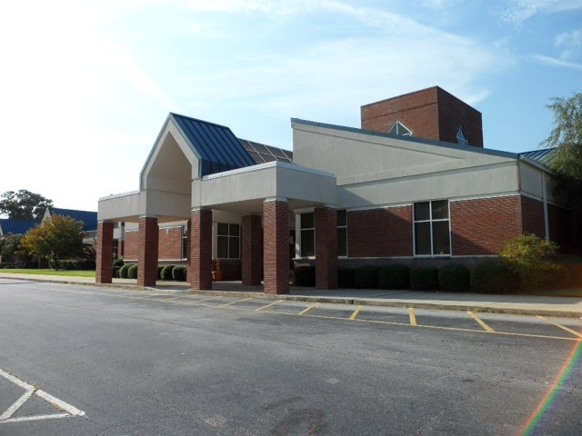

Vision Statement
The vision of Clayton County Public Schools is to be a district of high performance preparing ALL students to live and compete successfully in a global society.
​
Mission Statement
The mission of Clayton County Public Schools is to empower students to achieve academic and personal goals.

Why Dual Language?
- There is a “window of opportunity” that occurs between birth and
age 10 in which the likelihood of developing higher levels of
proficiency in a second language is far greater.

- When compared to a control group of their peers receiving English instruction, bilingual students generally demonstrated greater academic gains.

- By third or fourth grade, students generally tended to outperform comparable monolingual students.

- Not only do students develop proficiency in the target language, they also develop increased cultural awareness. The ability to interpret cross-cultural interactions is crucial in today’s world.

Our Program
The French Dual Language Program is a 50/50 bilingual educational program.

The academic day will consists of 50% of instruction in English (Language Arts/ Social Studies) and 50% of instruction in French (Math/Science), Students will be working together in small groups in English and French, which will result in increased learning for all students.

Over the next few years, students in grades kindergarten through five will receive literacy instruction in both English and French.

Program Goals
- Obtain high levels of achievement in all academic subjects
- Achieve true bilingualism and biliteracy of participating students
- Foster and promote cultural diversity and respect among all students

Parent Participation and Commitment
To ensure achievement and success it is necessary for families to commit to the program for at least six years (kindergarten through fifth grade).
Active parent support is extremely important to the long-term success of students participating in the Dual Language Program. Program benefits are achieved when students remain in the program for the duration. Helping your child with homework, attending parent conferences and providing feedback increases the likelihood of student success.

Application Information
Only accepting Kindergarten and 1st Grade applications for Fall 2020.
Please see the CCPS website for more information.
Directions:
Go to www.clayton.k12.ga.us
Click Departments
Click School Choice
Click Magnet Programs

Features of a
French Dual Language Program

Bilingual students generally demonstrate great academic gains

Research shows that students in language immersion programs can develop strong academic skills in addition to becoming proficient in both languages. Research shows that students receive a variety of cognitive benefits, such as greater creative thinking, mental flexibility, and the ability to think abstractly.

Students have the opportunity to achieve true bilingualism and biliteracy in French and English

Students learn languages more easily at an early age. Immersing and instructing students in the second language provides an effective vehicle for students to learn to speak, read and write proficiently in both languages by fifth grade.

Students develop cultural literacy as well as enhanced cognitive skills

Language immersion students benefit from the ability to communicate with people from diverse linguistic and cultural backgrounds.
Important Dates
February 5 – March 1, 2020
Late Application Window
CCPS Website

